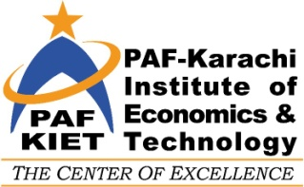
PAF-KIET
COLLEGE OF MANAGEMENT SCIENCES
BEST ACHIEVER AWARD
BATCHES 2003-2007

On the auspicious occasion of Alumni reunion 2003-2007; the College of Management Sciences has instituted a “Best Achiever Award” for the most performing graduates.
The Process includes a self evaluation appraisal by potential graduates, fill this form and submit it online on the website.
SELF EVALUATION FORM

Registration No. |  | Name
Graduating Class |  | Present Organization
Position/Post |  | Location
Contact No. |  | Email Address

Why do you think you deserve this award?

Achievements
1-

2-

3-

4-

My Profile (Employment History)
From | To | Organization | Position

Endorsement by two Supervisors:
NOTE: The institute will themselves obtain recommendations from your references.

Supervisor 1.

Name
Appointment Organization
Email
Telephone

Supervisor 2.

Name
Appointment Organization
Email
Telephone

Process
- On receipt of form necessary scrutiny will take place.
- A jury will be appointed to select 7 top achievers. The decision of the jury will be final.
- Last date of submission 25 Mar. 2016.
- Submit as attachment to kaenat@pafkiet.edu.pk

